Week of 6/10:

* Warm-Up
* Jump-Squat
  + 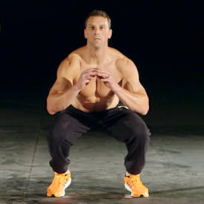3-4 sets of 8-15 reps
* One-Arm DB Row on Bench
  + 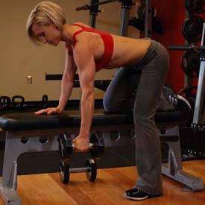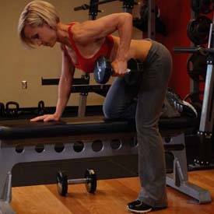4 sets of 8-15 reps
* Side-Lateral Raise
  + 3-4 sets of 8-15 reps
* DB Alternate Bicep Curl
  + 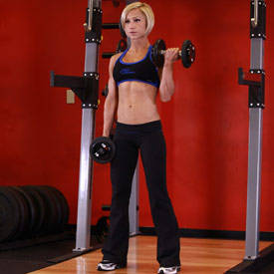3-4 sets of 8-15 reps
* Incline DB Press
  + 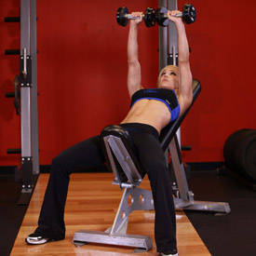3-4 sets of 8-15 reps