Junior Varsity “A”
# | Name | Class | Position | Starters
11 | Kylie Fetty © | 11 | D
30 | Kira Kaufman © | 11 | D
14 | Rosa Cunningham | 10 | M
13 | Alexis Ivory | 10 | F
5 | Molly Lenko | 10 | F
42 | Kristin Liming © | 10 | D
1/17 | Mia Martienz | 10 | GK
12 | Natalie Rickel | 10 | M/D
36 | Sarah Ryan | 10 | D
16 | Lydia Schroyer | 10 | D
24 | Emory Trout | 10 | M
10 | Sydney Kaufman | 9 | F
20 | Maggie Runals | 9 | D
18 | Jenna Sculli | 9 | F
15 | Miriam Smith | 9 | F
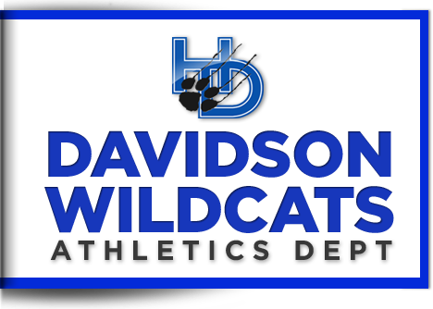
2019-20 Lady Cats Soccer

Junior Varsity “B”
# | Name | Class | Position | Starter
27 | Ellie Browning | 10 | D
6 | Gianna Colombini | 10 | M
19 | Leah Egelhoff | 10 | D
26 | Reese Kerr © | 10 | M
7 | Madelyn McDonough | 10 | M
23 | Libby Miller © | 10 | M
28 | Zuha Syed | 10 | M
40 | Lucy Gehrke | 9 | M/F
25 | Kellyn Hemmert © | 9 | D
8 | Brooke Jenkins | 9 | F
34 | Ashley Jimenez | 9 | M
35 | Emma Johnson | 9 | D/M
21 | Isabella Kennedy | 9 | D
29 | Samantha Koons | 9 | M
39 | Elizabeth Lynch | 9 | D
2 | Olivia Marginean | 9 | M
3 | Claudia Mullins | 9 | M
43 | Liliana Santiago | 9 | M
47 | Iris Shirvers | 9 | GK
4 | Eliza Smallwood | 9 | F
37 | Reese St. Pierre | 9 | D
9 | Brooklyn Upp | 9 | F

Varsity
# | Name | Class | Position | Starter
21 | Ellie Brorein | 12 | D
20 | Aidan Everett | 12 | M
5 | Erin Kodger | 12 | D/M
23 | Gretta Syrett | 12 | M
10 | Sonia Vargas © | 12 | F
11 | Alivia Wile © | 12 | F
2 | Megan Harper | 11 | M
25 | Grace Royer | 11 | F
15 | Kayla Stischok | 11 | F
12 | Sydney Stover | 11 | D
3 | Kayleigh Doherty | 10 | D
0 | Audrey Gibson-Zweifel | 10 | GK
6 | Kate Kodger | 10 | F
22 | Kierstyn Liming | 10 | F
13 | Khadija Seck | 10 | M/F
9 | Sydney Thompson | 10 | F
8 | Elizabeth Wile | 10 | D
16 | Emma Wells | 9 | M
00 | Ella Wickham | 9 | GK

Head Varsity Coach: Heather Coonfare
Assistant Varsity Coach: Trevor Lewis

Head JVA Coach: Kody Robertson

Head JVB Coach: Aaron Skipworth

www.DavidsonLadyCatsSoccer.weebly.com

